In the Matter of Faith Mueni
A mock case file for trial advocacy and marital property rights training in Kenya.

By Joel Ngugi
Associate Professor of Law
Chair, African Studies Program
University of Washington
William H. Gates Hall, Rm 315
Box 353020 Seattle, Washington 98195
Phone: 206-543-7611
Fax: 206-543-5671
www.law.washington.edu/faculty/Ngugi/

© 2009 Joel Ngugi

INTRODUCTION

In this case, Faith Mueni claims that she has been married to Alphonce Muoki for 13 years and that during the subsistence of that marriage they bought a 13-acre farm in Machakos. Faith claims their marriage was contracted under the Kamba customary laws. Their marriage, she says, produced three children: Sebastian, Stella and Ann. In the last two years, Alphonce has abandoned the family and last year he contracted marriage under the African Christian Marriage and Divorce Act to Alice Gachungwa. Alphonce claims although he had a brief relationship with Faith 13 years ago, he never married her; and they never jointly purchased the farm. He claims that he only allowed Faith to live on his farm on humanitarian grounds as his way of paying child support for the only child to come out of their brief relationship: Sebastian. Alphonce claims that he paid for the farm alone. He admits that he visited Faith’s family but only to stay in touch with his son, Sebastian.

Faith has brought a suit against Alphonce under section 17 of the Married Women’s Property Act of 1882 asking that the court allocate her half of the farm for her contribution to its purchase price. Section 17 of the Married Women’s Property Act provides:

In any question between husband and wife as to the title to or possession of property, either party ….. may apply by summons or otherwise in a summary way to any judge of the High Court of Justice…. And the judge of the High Court may make such orders with respect to the property in dispute, and to the costs of and consequent on the application as he thinks fit.

Alphonce has counter-claimed asking for eviction of Faith from the farm. He maintains that the farm belongs to him and is not owned jointly with Faith. His defense to this action is the same.

In order for Faith to succeed in her suit, she must establish:

- That she was legally married to Alphonce under Kamba customary laws; and

- That she made monetary contribution to the purchase of the farm and that the two spouses had an express agreement that the acquired property would be owned jointly by both of them so that it was registered in the name of Alphonce in trust for both of them.

In order for Alphonce to succeed in his counterclaim for eviction, he must prove:
- Sole ownership of the shamba;
- That there are no overriding (unregistered) interests in the land, for example, trust;
- That there is no subsisting valid tenancy agreement or, if any, that it has expired;
- That he has served proper notice to vacate the premises.

Faith will rely on her expert witness to establish that she was legally married to Alphonce under Kamba customary laws. She will try to establish her monetary contribution through evidence meant to demonstrate that Alphonce would not have been able to purchase the shamba but for the domestic arrangement with Faith that she pays for the family upkeep while he saves up to buy the property; and that this should be treated as monetary contribution.

Alphonce will rely on the evidence of the seller of the farm including the documentary evidence of the Sale Agreement to demonstrate that he bought the farm out of his own funds and without Faith’s contribution. He will adduce evidence that he was never married to Faith and never performed the requisite rituals under Kamba customary laws.
Important Assumptions

For purposes of this exercise, please make the following assumptions:
- The Sale Agreement is duly signed by both parties and properly attested by Advocate Kichana.
- The Sale Agreement is duly stamped after paying stamp duty.
- The sketch plan of the shamba (Exhibit A) and the official government map of the shamba (Exhibit E) are accurate.
- That there is a valid title deed and RIM (Registry Index Map) and both parties have, through a Notice to Admit, stipulated to that.
- That the photograph was taken by a business photographer, paid for by Mzee Nyamai. The photographer no longer lives in the village and cannot be found. No one knows where the photograph was processed.
- The photographs (exhibits C and D) are original and both parties have admitted their authenticity.

STATEMENT OF FAITH MUENI

My name is Faith Mueni. I am 35 years old. For the last twelve years, I have been married to Alphonce Muoki. We did not do a church wedding but he went to my parents, took dowry and asked for my hand in marriage. Exhibit C is an old photo of my parents dressed up at the betrothal. By that time, we were already living together in Machakos town where I was working as a waiter in a local hotel. Two years after he visited my family and was given permission to marry me, we bought a shamba near the Katumani Research Institute. The shamba is thirteen acres. I do not know the name on the title deed for the shamba because Alphonce was dealing with the seller and I left all of the details to him to do properly. There was no question that the shamba belonged to both of us however it was registered. I do not remember contributing any specific amounts to buy the shamba but during those two years, Alphonce asked me to take care of all the bills at home so that he could accumulate enough money to put in the down-payment. I kept a small diary of my earnings and the expenses because I was proud to be able to show Alphonce how careful I was with money.

The year after we bought the shamba, Alphonce asked me to move from the city to the shamba so that we could start building a home there. By then, we had one son – Sebastian Nyamu Muoki. So, I moved to the shamba in 2000. I grew maize, cassavas and millet in the farm and helped feed the family. Whatever remained, Alphonce would sell and use the proceeds to build the house I live in now. I made note of this money Alphonce gave me from the sale of the crops so I could show Alphonce my thrift. Alphonce remained in Machakos town because he had a good job as an Inspector in the Ministry of Education. He is now the District Education Officer in Machakos District.

In 2002, two years after we first moved to the shamba, I agreed with Alphonce that I should move our home to the southern end of the farm near the stream so that I could start a Dairy farm. We bought two Friesian cows and had fundis construct pens for them. A fundi also built a house for us there. By that time, we had added a second child, Stella Mwende, to our family. I have been working in the dairy farm since then. We produce a lot of milk in the farm. We use some of it as a family and sell the rest to neighbors. I keep track of the sales in my diary and have managed to buy two more cows, seven goats and a few chickens with the produce of the farm.

We got our third child, our last born, Ann Mutheu, four years ago.

Since I started the dairy farm, I agreed with Alphonce that he would use his salary to complete payment of the mortgage for the farm, and I would use the proceeds from the Dairy farm to pay for subsistence for the family and to send our children to school. As a result, I never received any financial support from Alphonce to raise our children.

After Alphonce finished paying off the mortgage, I asked him to start contributing towards the upkeep of the family. He became very hostile and said that it was my business to take care of my children since I had the farm. We quarreled a lot about this as I felt that I was straining too much to provide for our three children with only money from the dairy farm. I showed him the diary I kept to prove that I had been thrifty and needed his help with the family. When I requested Alphonce to help again, he became abusive verbally and physically and claimed that I had insulted him by saying that he is not “man enough” to provide for his family. He even yelled at me for “keeping book” on him and took my diary of income and expenses away. I have not seen it again.

Although at that time he used to come home every weekend, his visits became a lot more infrequent. After some time, he stopped coming home at all. That was last year March.

Two weeks ago, I noticed a construction at the Northern end of our farm. I approached the fundi who was in-charge (the same one who built my house and the cow pens) and he told me that he was constructing a house for Alphonce and his wife, Gachungwa. I was shocked. I immediately travelled to Machakos town to confront Alphonce. When I got to his house, I met another woman who introduced herself to me as his “wife.” Her name is Alice Gachungwa. When Alphonce came home, he started shouting at me that I had no business being in his house and I should leave immediately. He told Alice that I was a “mad woman” for claiming that I was his wife because he doesn’t have another wife except Alice. He showed me a marriage certificate indicating that they got married in a Catholic Church on April 16, 2008. Alphonce claims that I am just a long term tenant in his farm and not his wife. I was very upset but did not want to cause a scene – so I returned home.

The following day, I received a hand-delivered letter from Alphonce’s lawyers stating that it was the requisite 15-day notice to end the month-to-month lease I had with the owner of the shamba, Alphonce Muoki, and that failure to vacate the premises by the end of the following month will result in eviction proceedings.

I would like to file a suit to block my eviction from the farm and to demand that a court of law apportions me my equitable share of the farm.
Faith Mueni
STATEMENT OF ALPHONCE MUOKI

My name is Alphonce Muoki. I am 43 years old and currently have the position of District Education Officer of Machakos District. I am married to one wife – Alice Gachungwa – and we have one child, Alexander Muli Muoki. Alice and I got married in May, 2008, at the Holy Trinity Catholic Cathedral in Machakos town. I have not been married previously although I had a brief sexual liason with Faith Mueni about thirteen years ago. Our relationship lasted no more than ten months. We got one child together – Sebastian Nyamu Muoki. After our brief relationship had ended, Faith contacted me six months later and informed me that she had lost her job as a waiter and needed a place to stay. I suggested to her that she could move to my farm near Katumani Research Institute as she gets her feet on the ground again. I did this because I cared about my son and did not want him to suffer. I bought the farm alone; I did not receive any contribution from Faith or any other person. Faith promised that she would work the farm for a while and raise enough money to buy her own plot. For humanitarian reasons, I decided not to charge her any rents but I made it very clear that I would ask her to move in the future when I got married and needed to settle there.

I purchased that shamba from my long time friend, Charles Muema. I paid for it with my own funds for the down payment of Kshs. 50,000 and a bank loan using my own personal credit to pay off the balance. I registered the land in my own name as I bought the land personally.

About seven years ago, I visited Faith at the farm and told her that I would need her to start thinking about leaving the farm because I was engaged to another woman and we were planning to start a family at the farm. Faith pleaded that she was not ready to move yet. I advised her to start a more profitable business – like dairy farming – so that she could accumulate funds more quickly to buy her own farm. Following our conversation, and with my approval, she moved her homestead to the southern end of the farm and started a Dairy Farm. I think the Dairy business has been successful because she has managed to support her family of three children without any problems. On my side, I have treated my letting Faith use my farm rent-free for more than thirteen years as my contribution to child support for Sebastian. Faith’s other two children are not mine.

Two weeks ago, Faith came to my house in Machakos town and made claims to my wife that she is my “wife” and that I had “abandoned” her and “my children.” Nothing can be further from the truth. Faith and I have never been married and we have certainly never had a marriage ceremony together. I visited her family once – when we were boyfriend and girlfriend – but not for courtship of any kind. We only lived together for one year – and only as boyfriend and girlfriend. I visited her home over the weekends because I wanted to spend time with my son. I let her live on my farm for thirteen years out of my own generosity and now she wants to abuse my generosity. I need her out of my farm immediately. I have already asked my lawyers to serve a notice for her to vacate my farm. It is Exhibit F. I am ready to pay child support for my one son – Sebastian. Faith’s other two children are not mine and I am not responsible for them.

The people shown in Exhibit D are my friends from school. The photograph was taken at a reunion party we had about 10 years ago.

Alphonce Muoki
STATEMENT OF MZEE NYAMAI KILONZO
(Expert witness for Mueni – on Kamba customary laws on marriage)

My name is Nyamai Kilonzo wa Wambua. I am 85 years old. I live in Makueni. I have lived there throughout my life. I know Faith Mueni very well. She is the daughter of my friend Kilukumi Musau, who unfortunately passed with his wife two years ago in a tragic road accident. I remember attending the uthoni of Mueni more than ten years ago. We were called by Mzee Musau to be guests in his house as the family of the groom was visiting. I was part of the panel of wazee who were negotiating with the groom’s side. The groom was Alphonce Muoki. He came accompanied by a group of his people. They came in minibuses. I remember being impressed by the way they were dressed.

I kept an old picture of some members of the group, and it is Exhibit D. That photograph and the photograph of Faith’s parents (Exhibit C) was taken by an itinerant photographer who used to come by our village for ceremonies and sell his photographs to the people who came. I do not remember the name of the photographer. He has not come by our village for many years. Alphonce paid the photographer for these photographs for me to keep. I kept both of these photographs in a stack of photographs I keep to memorialize the important events in our village. The other elders and I are the memory of our community and I have an obligation to maintain some memento of each important event. This is what I kept for Faith’s wedding.

When they arrived, in accordance with Kamba customary rules, Alphonce and his group were asked to sing until the group congregated at Mzee Musau’s home felt satisfied with their singing. Then, the women in their group were asked to go to the kitchen and cook for everyone. As per tradition, they had brought their own food to cook. Everyone going for uthoni in Kambaland knows to carry the food they will cook on the day of betrothment.

After food was served, one elder from our group asked an elder from Muoki’s group to explain their mission in my friend’s home. The elder from Muoki’s side explained that they had come to ask for Mueni’s hand in marriage. Our elder asked them if they knew the procedures and they responded in the affirmative. According to the Kamba traditions, Muoki’s entourage was expected to “put beacons” to symbolize that they have “booked” Faith first. They did this by paying Kshs. 7,000. Next, we began negotiations for bride-wealth. We negotiated for a long time – well into the evening. In the end, we agreed that Muoki will pay one hundred goats, a debe of honey, four crates of soda for the women, and four crates of beer for the elders. His elders asked if he could be permitted to pay part of it and marry Faith and then pay the rest later. It was agreed that he could pay for ten goats at Kshs. 1,500 per goat, the debe of honey, the soda and beer. He paid a total of Kshs. 25,000 for all these. The women then danced and sang because we had successfully completed important negotiations.

Muoki has never come back to Mzee Musau’s home since that time – but we, as the elders, had already given him our blessings to marry Mueni. As far as Kamba customary norms are concerned, Muoki and Mueni are legally married. A few years ago I heard from Mzee Musau that Muoki and Mueni have been blessed with three sons.

That’s all.

Kilonzo

STATEMENT OF CHARLES MUEMA

My name is Charles Muema. I am an unmarried businessman, but have two children by Grace Muthemba who keeps my large farm near Kaani. I know Alphonce Muoki very well. I have known him since we were both children in school in Machakos together.

Since I had purchased my larger farm and needed some cash, I sold Alphonce my shamba L.R. 9999 in Machakos district about thirteen years ago. I sold the shamba for Kshs. 260,000. Alphonce paid a down-payment of Kshs. 50,000 first and then the rest was paid through the Kenya Commercial Bank about three months later. He applied and got a loan to clear the balance. We entered into a Sale Agreement which was drawn by Alphonce’s lawyer in Machakos. Here is the Agreement (Appendix B). As you can see from the Agreement, the only person I sold the shamba to is Alphonce. To the best of my knowledge, Alphonce was single at the time. He never mentioned any wife, although he did tell me that he had a son of whom he seemed proud. He paid all the monies on his own. I never saw Faith Mueni during all our negotiations and I had never seen her before these proceedings.

Alphonce came to visit about a week ago. I had not seen him in years, but he is still a good friend. He brought me an entire case of Guinness stout, of which I am very fond, but it is impossible to get in Kaani.

That’s when I learned that Faith Mueni claims to be Alphonce’s wife. I was surprised. If Faith’s claims were true, I would have known when we were negotiating the sale of the farm. It would have been odd to negotiate a whole deal and never once to see the wife. I have bought and sold many other parcels of land. At other times when a man tells me he has a wife, he has asked that his wife be listed on the sale agreement so that there is no question. And that is why Grace’s name is not on any of the papers for my farm. She is not my wife, as I often tell her when she makes demands for money from me.

That’s all.

Charles Muema

STATEMENT OF ALICE GACHUNGWA

My name is Alice Gachungwa. I am 23 years old. I was educated by the nuns at St. Catherine’s Catholic School and received a diploma for making it all the way through secondary school. After finishing school, I worked, actually mostly volunteered because there was so little pay, as personal assistant to the Mother Superior. After a while she pulled some strings with a friend of hers in some government agency and got me a real job as an office clerk at the District Education Office.

After a little while on the job, the District Education Officer, Alphonce Muoki, became very friendly with me. He was always very nice and polite. He told me that I was pretty and gave me little gifts. Then he got a friend in the Water Department to offer me a job as his personal secretary. I accepted the position because it was a promotion.

At first I was suspicious of Alphonce’s attention because he is about 20 years older than me and I know some men play with girls in town but have wives in the country. I been raised to be a very devout Catholic by my parents and did not want any part of that stuff. I asked around. The people in the District Education Office had not ever been told by Alphonce of having a wife. They had had not heard of him having a wife, or playing around with girls from anyone else. Just to be sure, I talked with Mother Superior about him. He has a lot of connections with priests and other people who know things. She told me that as far as she could find out, he was a good and hard working man and not married.

Two years ago, Alphonce asked me to marry him. I was very happy, but before I would agree, I told him he had to get my father’s blessing. As we are Catholics, we do not follow customary laws or require a payment of dowry, but I am devoted to my parents and wanted them to agree to any husband. Alphonce visited my parents home and asked for my hand in marriage. My father agreed that he could marry me because he has such a good position. I think that my father talked to the priest as well. We were married in the St. Alonzo Catholic Church on April 16, 2008, and I have lived with Alphonce ever since. We were blessed with a son this February.

Two weeks ago a woman came to our house in Machakos town. She said her name was Faith Mueni and she was Alphonce’s wife. I knew this could not be true because no one I talked to in Machakos town had ever even heard of Alphonce having a wife.

Alphonce became very angry at her false accusations. He said she was crazy for making this claim. She is just someone who was a tenant on his farm. He had even let her not pay the rent for a while because she did not have the money and needed it to support her children. After a while, Alphonce admitted to me that she had been his girlfriend many years ago and that he had an 11 year old son, Sebastian, by her. I have forgiven Alphonce for not telling me about this because I know how men are. But I also know that Faith Mueni is not Alphonce’s wife because I am his wife.

That is all.

Alice Gachungwa

STATEMENT OF JOMO OBAMA
My name is Jomo Obama. I am 49 years old and have lived in Ianzoni my entire life after my parents moved there from Kogelo when I was two years old.. I rarely even go to Machokos town, except occasionally to buy things I need that I cannot get in the market. My wife is Makena Wanjiru, who has blessed me with nine children. Because we have made a life together, I consider Makena to be my wife, even though we did not get married in a church. Neither did I pay Makena father a dowry. We could not afford to set up a household together if I had paid a dowry. She just moved in with me as my wife and has lived with me ever since.

I make my living as a fundi. Over the years, I believe I have gotten a reputation as being very good at working on the houses and cattle pens around Ianzoni. Many years ago, Alphonce Muoki came to me and told me that he and his wife, Faith Mueni, had just bought a shamba nearby and asked if I could help with some construction. He said that they wanted to build a house and some cattle pens to start a dairy farm. Since he had spent all of his money on buying the shamba, he said he had very little money to pay for new construction. But he told me that his wife would grow crops and sell milk from the cows to have extra money to pay me little by little.

People often ask me to build for them and I have learned that it is important that they pay cash for the construction materials so that I do not lose money out of my pocket. But to build my business, I will let people pay for my work little by little. Alphonce paid me some money for new materials, and we took down some old sheds and found some wood on the shamba to build the small house for Faith and her child and the cattle pens. Alphonce came to me and paid me money about once a month for the next year or two to pay off the cost of the construction little by little. I often saw Faith in the market selling milk and crops. I bought milk from her from time-to-time myself. She certainly was a hard worker. As the years went on, though, she seemed to look more tired and skinny every time I saw her.

About six months ago, Alphonce came to me again and asked me to assemble many helpers to build a large house. He showed me a grand plan. He told me he now had a great deal of money because he had paid off the mortgage to the shamba and had a good job in Machakos town as a District Education Officer. He wanted to build this house for his young, pretty church-wed wife. I was surprised because I had always been told that Faith was Alphonce’s wife. But I did not say anything because it is not my business. Besides this grand new house was big business. It is a large project and this time he will not pay me little by little. It is all cash.

Exhibit A is a sketch plan of the shamba that I prepared from specific measurements made by me and my assistant. We made it to prepare a site plan for the new construction. I take pride in my work, and this is accurate.

That is all.

Jomo

EXHIBIT A
Sketch Plan of shamba
Drawn to scale by Jomo Obama as a site plan for the new construction

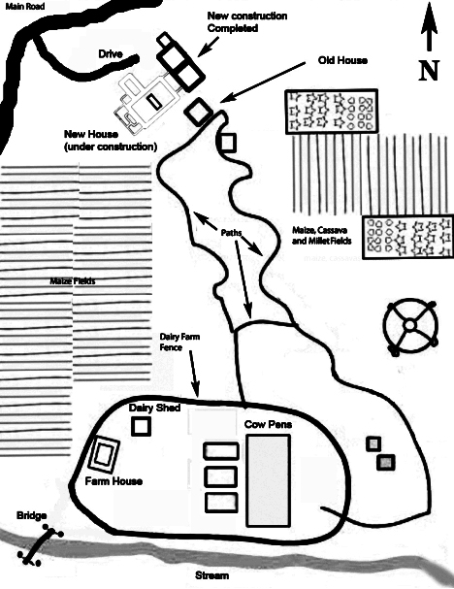

EXHIBIT B

Sale Agreement between Alphonce Muoki and Charles Muema

SALE AGREEMENT

THIS AGREEMENT is made this 31st day of July One Thousand Nine Hundred and Ninety Seven by and between CHARLES MUEMA ID NO. 040404040 and P.O. Box 44444 Kaani in the Republic of Kenya (hereinafter called the Vendor) which expression shall where the context allow include his personal representative assigns and or nominees of the one part and ALPHONCE MUOKI ID NO. 15151515 of P.O. Box 55555 Machakos of the other part (hereinafter the Purchaser) which expression shall where the context allow include his personal representative assign and or nominee of the second part.

WHEREAS

- The Vendor is the registered owner of all that Parcel of land identified as L.R. 9999 Machakos.

- The Purchasers are interested in purchasing the said property.

NOW THIS AGREEMENT WITNESSETH

1. The Property sold is all that parcel of land identified as Land Reference No. 9999 Machakos.

2. The interest in the land is a freehold.

3. The Purchase price which is all inclusive is the sum of Kenya Two Hundred and Sixty Thousand (Kshs. 260,000.00) payable as hereunder.

- Kenya Shillings Fifty Thousand (Kshs. 50,000.00) to be paid on execution of this agreement and receipt whereof the Vendor hereby acknowledges.

- Kenya Shillings Two Hundred and Ten Thousand (Kshs. 210,000) to be paid on or before 31st October 1997.

4. The completion date shall be Seven months (7 months) from the date of execution of this agreement.

5. The sale is subject to the conditions contained in the 1989 edition of the Law Society Conditions of Sale so far as they are not inconsistent with the conditions contained in the agreement.

6. The Parties Advocates are Messrs. Kichana & Kagiri Co. Advocates, Kilunda House, P.O. Box 6666 Machakos.

7. The formal transfer of the property shall be made to the Purchasers and/or their nominee.

8. The Vendor confirms that he has good title to the Property and undertakes to indemnify the Purchasers in respect of any demands or claims in future from any persons or authority in regard to the property.

9. Special Conditions

a) The Purchasers having inspected the property have notice of the identity thereof and of its actual state and condition and takes it subject to such state and conditions. The Vendor undertakes to show the Purchasers and or their representatives the Property and to make it accessible for their inspection at least once before the actual survey of the Property.

b) The Vendor is responsible for obtaining the consent to transfer and in the event it is denied then the transaction shall fail and the Vendor will refund all the moneys paid unconditionally.

c) Time shall be of essence in respect of all the obligations of the parties hereunder.

d) The Purchaser shall pay stamp duty, registration fees and all the costs related to the transfer.

e) The Vendor will directly process the title in favour of the Purchaser.

IN WITNESS WHEREOF this agreement has been sealed signed and delivered on the date and year first herein before written.

Signed by the Vendor )
CHARLES MUEMA ) Charles Muema
in the presence of: Alice Kichanga )
)
)
Signed by the Purchaser )
ALPHONCE MUOKI ) Alphonce Muoki
In the presence of: Alice Kichanga )
)
)
ADVOCATE
DRAWN BY:
KICHANA & KAGIRI CO. ADVOCATES
KILUNDA HOUSE
P.O. BOX 6666
MACHAKOS

EXHIBIT C

Photograph of Mzee Kilukumi Musau and Prudence Odhiambo, Faith’s parents.
Taken by itinerant photographer at ceremony.
Purchased by Alphonce and given to Mzee KILONZO to keep as a memorial of the ceremony.

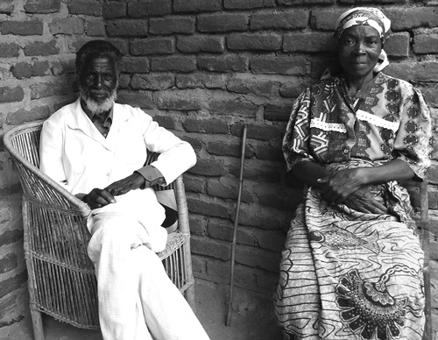

Exhibit D
Photograph of Alphonce Muoki Bridal Negotiating Party
Taken by itinerant photographer at ceremony.
Purchased by Alphonce and given to Mzee KILONZO to keep as a memorial of the ceremony.

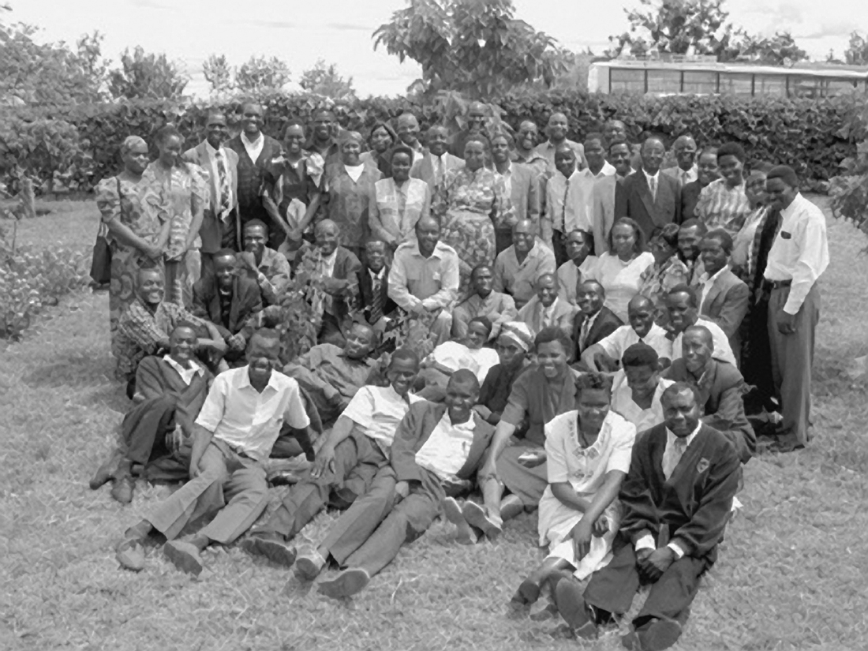

Exhibit E

Map of shamba Location
Map is official government map and is accurate.
Location of shamba and Katumani Research Institute are marked by Faith and are approximate.

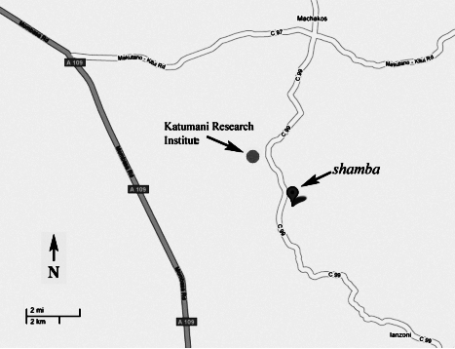

EXHIBIT F

Notice to Vacate Premises

KICHANA & KAGIRI CO. ADVOCATES

KILUNDA HOUSE
P.O. BOX 6666
MACHAKOS
____________________________________________________________

August 7, 2009

TO: FAITH MUENI
P.O. BOX 77777
MACHAKOS

Re: Notice to Vacate Premises – L.R. 9999 – Machakos

Dear Faith Mueni:

Acting under instructions from our client, Mr. Alphonce Muoki, we address you as under:

Our instructions are that you have been a tenant on a month-to-month lease at our client’s property registered as L.R. 9999 Machakos in his name for the last twelve years. Our further instructions are that while you did not pay rent in monetary form, our client allowed you to remain in the said property as part of his support for the child you bore together. Our client is, however, no longer in a position to continue having you as a tenant in his property. Consequently, he has instructed us to serve this notice on his behalf.

TAKE NOTICE that you are hereby required to vacate all the premises located on LR 9999 Machakos by the close of business on August 21, 2009. Further take notice that failure to adhere to this notice will result in legal action for eviction at your sole risk as to costs without further reference to you.

Yours faithfully:
Alice Kichanga
Agnes Kichana

Based on Echaria v Echaria, H.C.C.C. No. 4684 OF 1987 (O.S.)
All Rights Reserved. These materials may not be reproduced without the express written permission of the author.

